ELCT 201 – EE Laboratory 2

ResiStive Sensors, Op-AMps, and Power Supplies

Jacob Vaught
09/20/2022

Department of Electrical Engineering
University of South Carolina
Columbia, SC 29208

Abstract
A set of exercises taught basic use of the oscilloscope “math” function, power supply series/parallel tracking, Op-Amp usage, and resistive sensors. The oscilloscope math controls were found to be especially important for determining the gain of an amplifier, while the time (horizontal) controls were important for displaying interesting features at a size that was appropriate to see and measure. The function generator was used to produce a 10kHz 5 V_{rms} signal to the circuit in one exercise. The Power supply series tracking was used to combine two 7 V signals to create a total voltage of 14 V in the linear Op-amp exercise. The oscilloscope was used to view how resistive sensors can be used to control other electrical components, and the Op-amp was used as a comparator and a linear amplifier. The exercises also facilitated the use of datasheets to determine critical component information.

Introduction
A series of 3 circuits were built to facilitate the use of the components listed in the introduction. The first circuit shown in Figure 1 was used 4 times to demonstrate the difference between 2 resistive sensors and how to implement them for 2 different hypothetical scenarios.
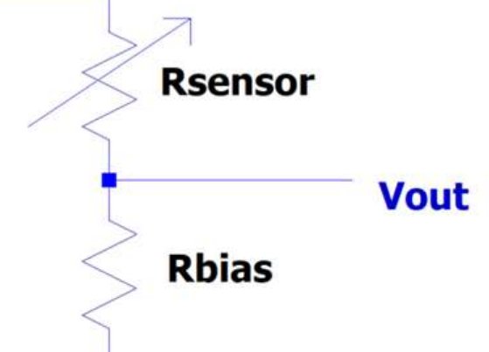
Figure 1 shows the resistive sensor and 10kΩ resistor in series together.
The second circuit as shown in Figure 2 demonstrates the op-amp being used with the resistive sensors as a comparator. was used to demonstrate using the resistive sensors in practical scenarios, by utilizing an Op-amp to turn an LED on/off.
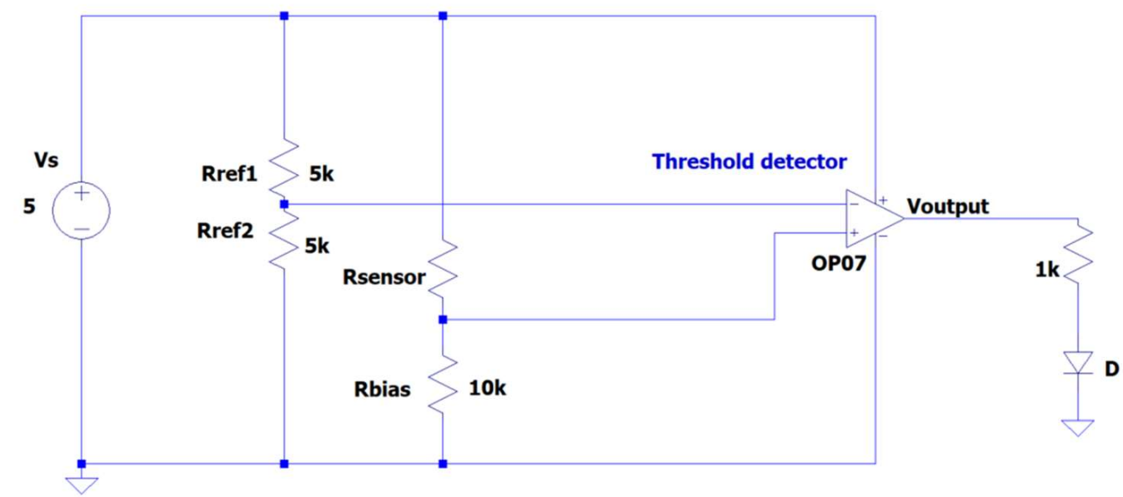
Figure 2 demonstrates the op-amp being used with the resistive sensors as a comparator.

The third circuit as seen in Figure 3 utilized the op-amp to demonstrate a linear amplifier, varying an LED’s brightness depending on the ambient brightness. This circuit was also used to demonstrate series/parallel tracking in a power supply.
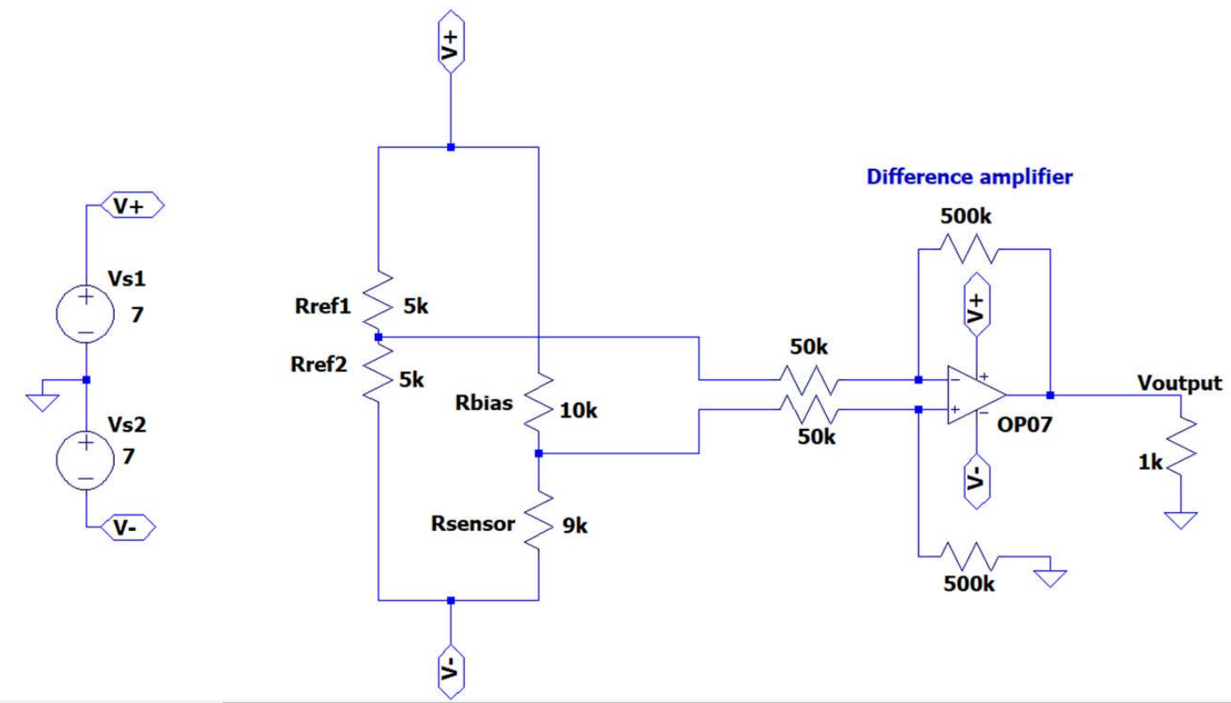
Figure 3 shows the op-amp connected to a resistive sensor being used as a linear amplifier to vary the LED brightness

Prelab Calculations
The needed data to complete the prelab includes the resistance of the photoresistor at 10 lux and 500 lux, and the resistance of the thermistor at 20 °C and 40 °C. Using the datasheets, the results for the thermistor are 12488Ω and 5330Ω respectively. However, the photoresistor has a complication due to the datasheet not including a table. The datasheet only includes a graph, as shown in Figure 4. The estimated resistances are 9.5kΩ and 0.1kΩ respectively.
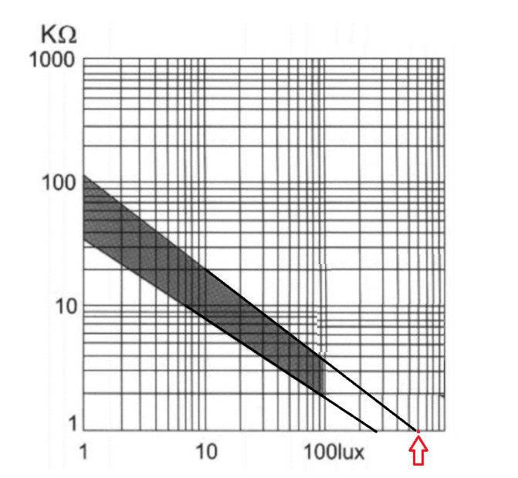
Figure 4 shows the provided graph in the datasheet, with an extrapolation being performed to find the estimated resistance.

Circuit 1a(Photoresistor)
For this exercise, a photoresistor was used in series with a 10kΩ resistor. The bench equipment used included the DMM, Function Generator, DC Power Supply, and the Oscilloscope. First, each circuit was powered via the DC Power Supply, then powered via the function generator with input signal parameters of 5 V_{rms}, 10 kHz.

photoresistor before Bias Resistor
The circuit used here is shown in Figure 5. It was seen that voltage increased when luminosity decreased, and the voltage decreased when a luminosity was increased. However, a decrease in current was noted when luminosity was increased. The results from decreased and increased luminosity when the Function Generator was attached can be seen in Figure 7 and Figure 6 respectively. The current was read as 0.44 mA, however the current was calculated as 0.468 mA.
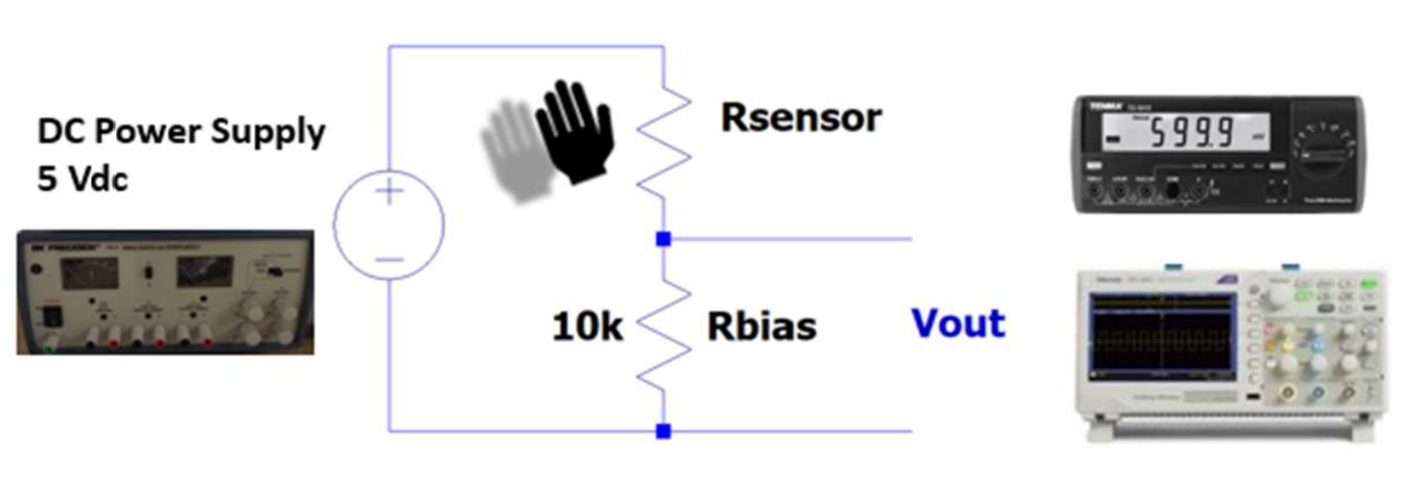
Figure 5 shows the circuit used in Circuit 1A. The DC Power Supply gets replaced with the function generator in later sections of the procedure
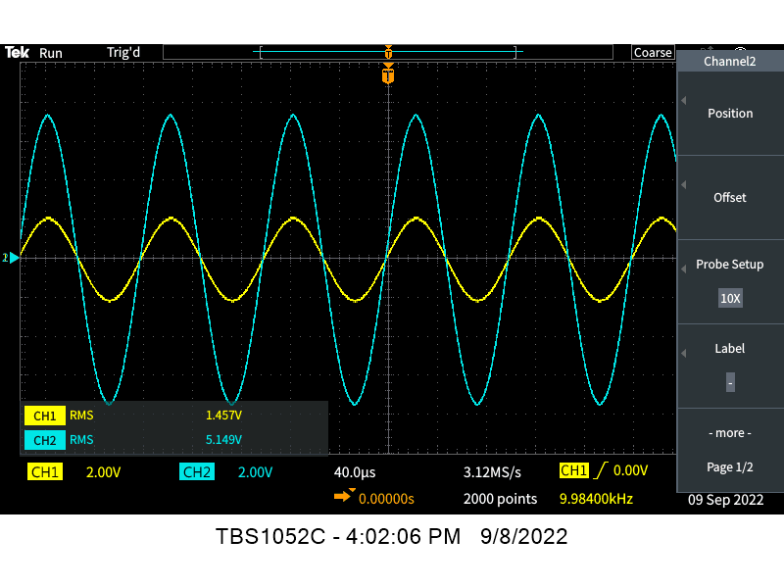
Figure 6 shows the results of the ambient lighting in the lab shining on the sensor.
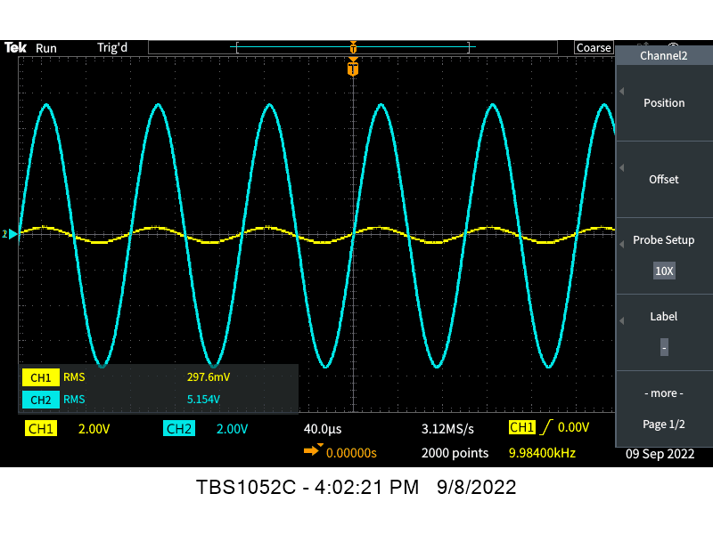
Figure 7 shows the results of the on almost 0 lux of light shining on the sensor

photoresistor After Bias Resistor
The circuit used in this part of the exercise is similar to the one shown in Figure 5, however, the resistor and the resistive sensor are swapped. It was now seen that voltage decreased when luminosity decreased, and the voltage increased when a luminosity was increased. However, an decrease in current was still noticed when luminosity was increased which was unexpected, but was found to be expected after completing some basic equations.

Circuit 1b(Thermistor)
For this exercise, a thermistor was used in series with a 10kΩ resistor. The circuit is identical to the one in fig 5, however, it has a thermistor instead of a photoresistor. The bench equipment used included the DMM, DC Power Supply, and Oscilloscope. The circuit was powered via the DC Power Supply with the non-variable voltage of 5 V.

Thermistor before Bias Resistor
Figure 8 shows the time variation of the output voltage as the thermistor warms up from room temperature (about 20 C) to body temperature (about 40 C). From the image, it seems that it takes approximately 2 time divisions to reach body temperature, which is approximately 8 seconds. One thing to note is that it takes many times longer to settle back to room temperature. It took approximately 5.5 time divisions to get back to room temperature, which is 22 seconds.
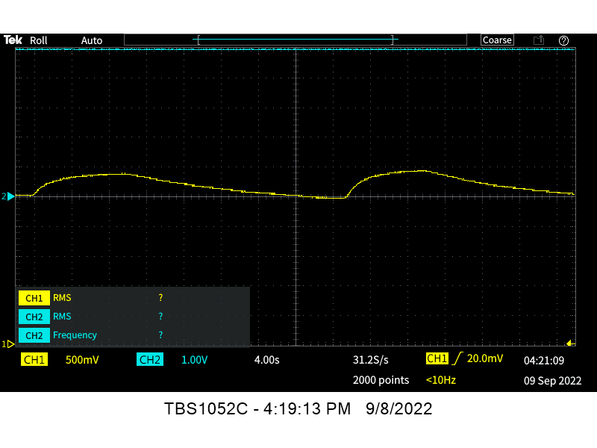
Figure 8 shows the time variation of the output voltage as the thermistor warms up from room temperature (about 20 C) to body temperature (about 40 C)

Circuit 2(Op-AMp as comparator)
In this exercise, an operational amplifier was utilized to make a comparator. A comparator compares 2 voltages (negative and positive terminals on the op-amp diagram) and when the terminal has a higher voltage than the reference voltage, the comparator has an output. It can also be thought of as a digitized relay. The reason a potentiometer is needed in this exercise is to change the reference voltage so the output can be varied. It would be inconvenient to have the LED be on at all times!
The DC power supply was once again utilized, and the constant 5 V supply was used. A 10kΩ potentiometer was utilized, in addition to a LM324 Quad op-amp IC chip. The circuit shown in Figure 9 was constructed and a series of tests were run.
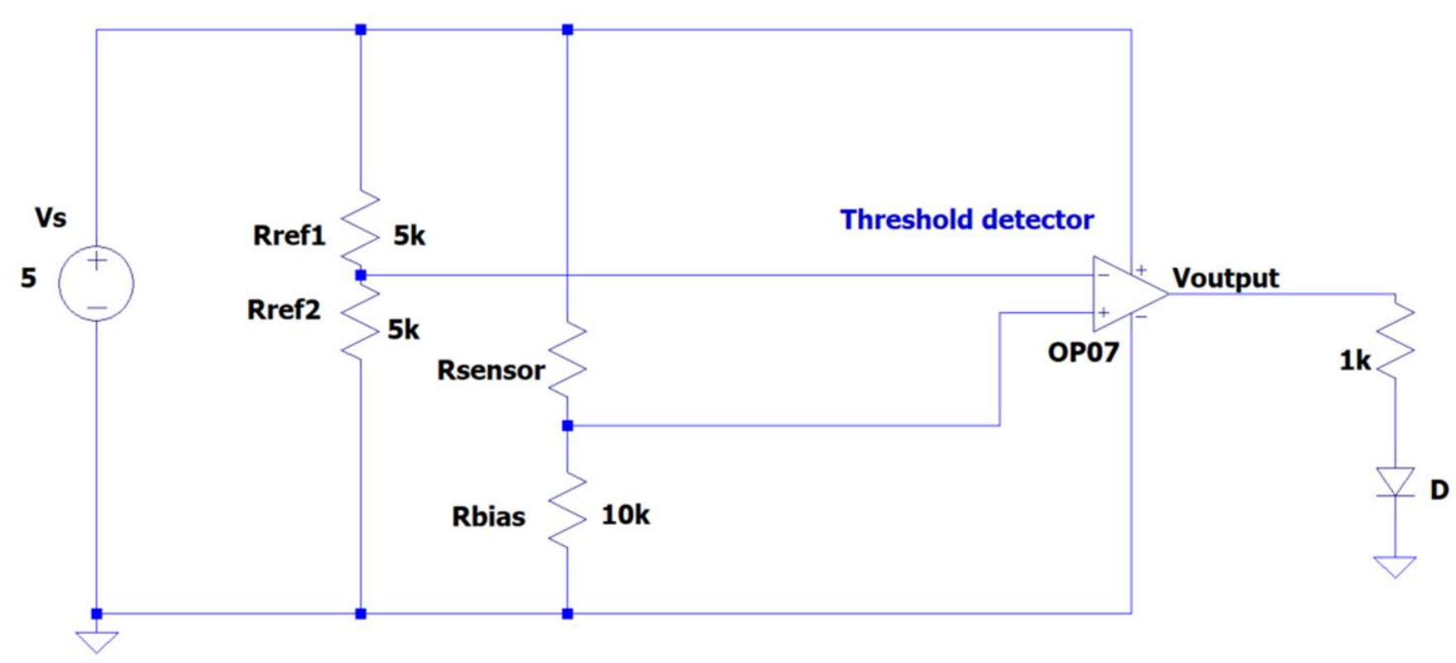
Figure 9 shows circuit with the op-amp as a comparator for a resistive sensor.

Photoresistor as a Resistive Sensor
When the luminance of the sensor dropped below a certain point, the LED would switch on, as a streetlight would at dusk. The potentiometer was set to a value that cause the LED to turn on immediately after the luminance was less than the lab’s ambient luminance. Figure 10 shows a “hand-waving” event where luminance fluctuated rapidly, and the corresponding output of the comparator.
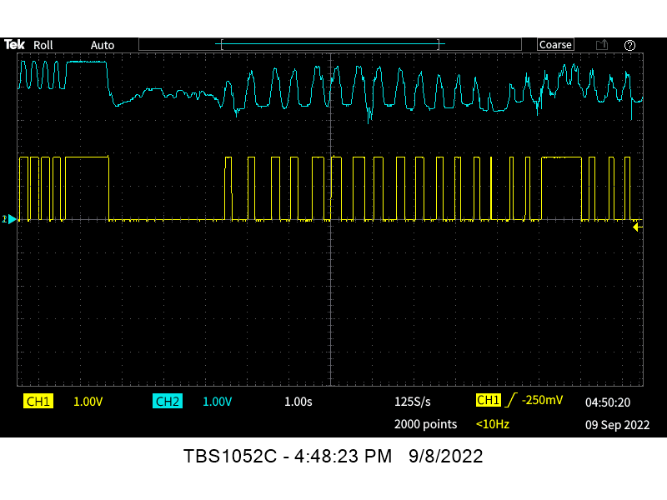
Figure 10 shows the photoresistor luminance varied rapidly, and the corresponding output.

Thermistor as a Resistive sensor
When the temperature of the sensor dropped below a certain point, the LED would switch on, as an AC compressor would turn on after reaching the desired temperature. The potentiometer was set to a value that cause the LED to turn on immediately after the temperature was more than the lab’s ambient temperature. shows the thermistor warming and cooling down after using body heat to increase the temperature from 20 to 40 C and the corresponding output of the comparator.
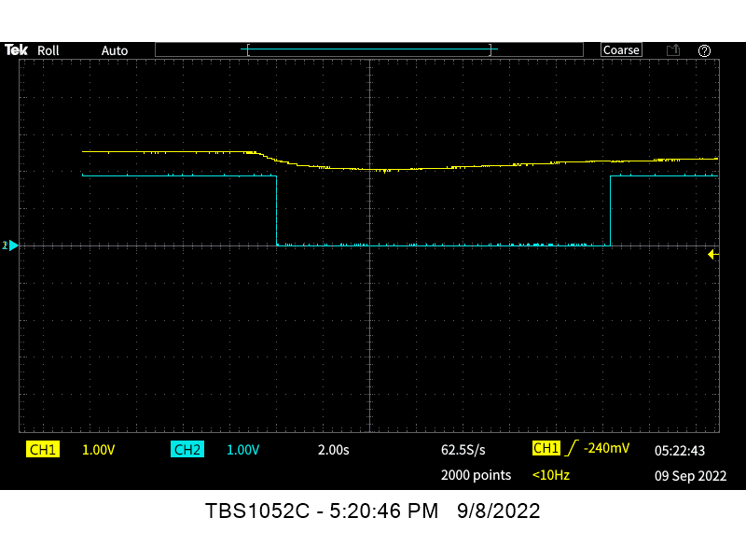
Figure 11 shows a thermistor being heated to body temperature, then returning to room temperature

Challenge Problem (OP-AMP & Series/Parallel power supply tracking)
In this exercise, an op-amp was utilized to make a linear amplifier as shown in Figure 12. This means that the output voltage is proportional to the input, whereas the comparator was either on or off. The DC Power Supply was put into Series tracking mode to add two 7 volt supplies to create a 14-volt power supply.
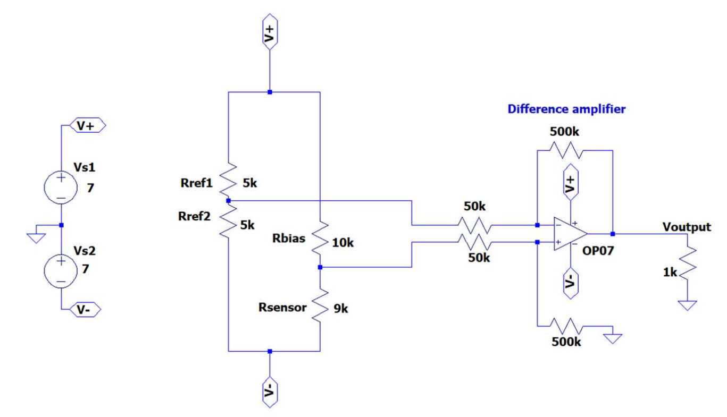
Figure 12 shows the op-amp being used as a linear amplifier.
The Math function on the oscilloscope was used to calculate the difference between channel 1 and channel 2 as shown in Figure 13. In the same figure, the output voltage, channel 1, can be seen to vary. An incorrect image was taken. It was supposed to show input voltage of resistive sensor vs output, instead the figure shows DC power supply vs output voltage.
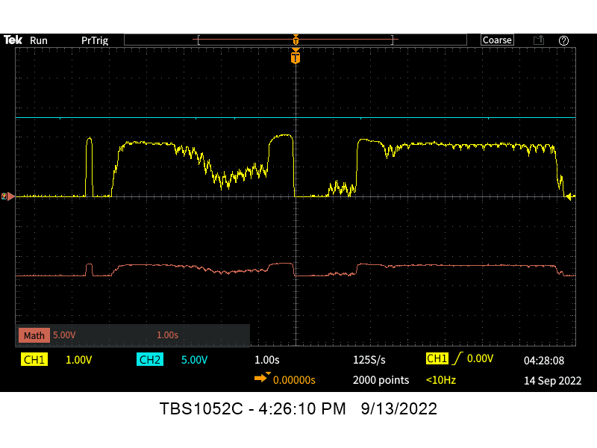
Figure 13 shows the Math function being used and shows the linear amplifier.
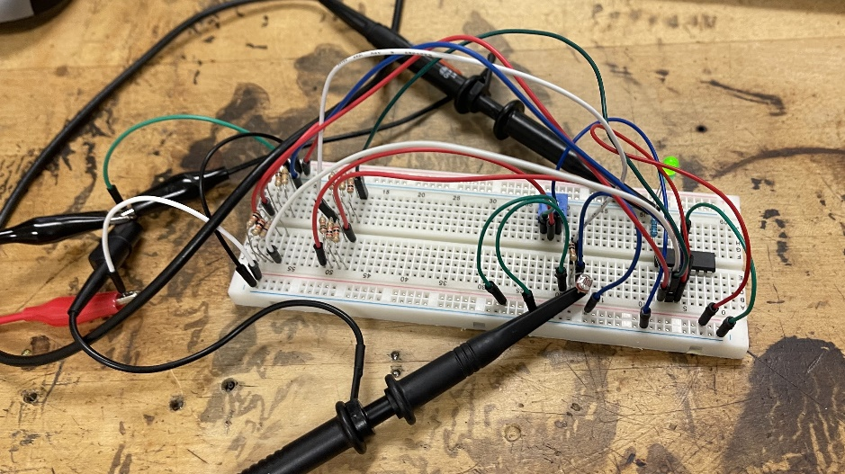
Figure 14 shows the physical circuit built.

Interesting results from an unplanned USer error
Something of interest was the surprising fact that if a 14-volt power supply was used without using series tracking, the circuit still functioned as expected. The erroneous circuit built is shown in Figure 15.
Figure 15 shows the erroneous circuit built with a single power supply.

Conclusion
The lab provided invaluable learning experiences to students and increased knowledge in bench equipment dramatically. The results of the experiments all matched what the pre-lab had predicted, however there were a few differences due to different components being provided. The linear amplifier challenge problem was quite interesting, especially since it taught valuable troubleshooting skills. The skills learned here will be valuable for future labs and for the final project involving an FM radio.

Acknowledgements
The completion of this lab could not have been possible without the expertise and knowledge of Dr. Roger Dougal, the professor of this class. A thought of appreciation is also owed to the TAs, Rabab Abdelfattah and Ritwik Nag, for providing clear and helpful instructions when completing the exercises. The lab manager, Mr. Joe Gucwa deserves our thanks for making these exercise possible with all the equipment he provided for use in the exercises. Last but not least, with the utmost gratitude, Peer Mentor Daniella Mallari must be thanked for all the time and care she put into the next generation of students. She has provided excellent care in ensuring all lab topics are well understood and was extremely patient with all students.

